In this assignment, I will cover the implementation of

Authentication-Service. This service will allow two major features:

1. Authenticate users via token mechanism, which will later allow to:
2. Authorization access with specific roles to each resource after authenticating.

The implementation of the service along with additional modification at existing services which are involved as resources, such as Organization Service and Asset Service.

Running mvn clean package docker:build :

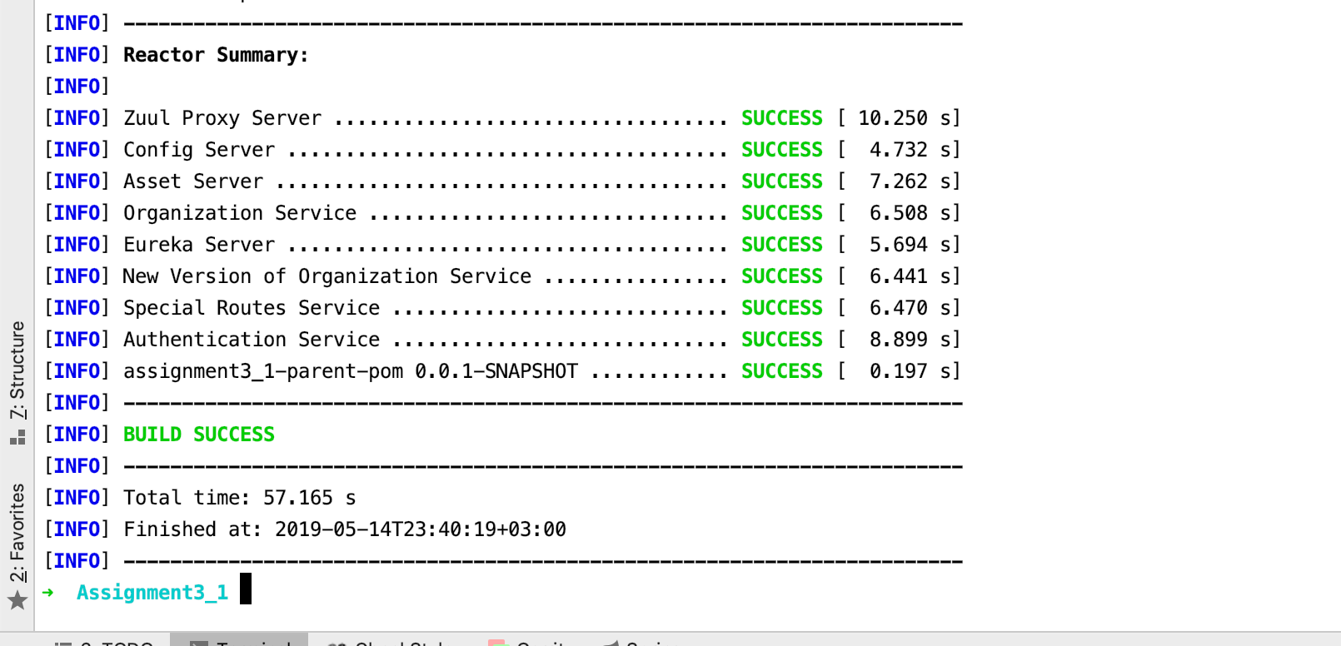

**docker-compose -f docker/common/docker-compose.yml up**

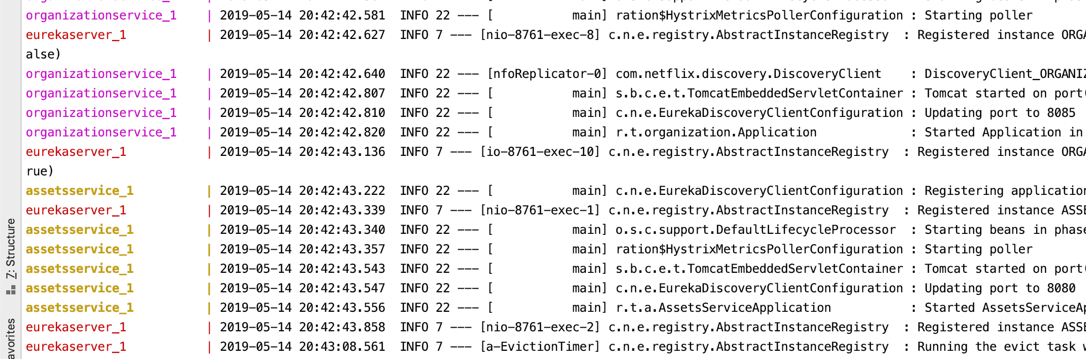

Use Case 1 – Access is restricted only to authenticated users:

Attempting to get organization details without authenticating.

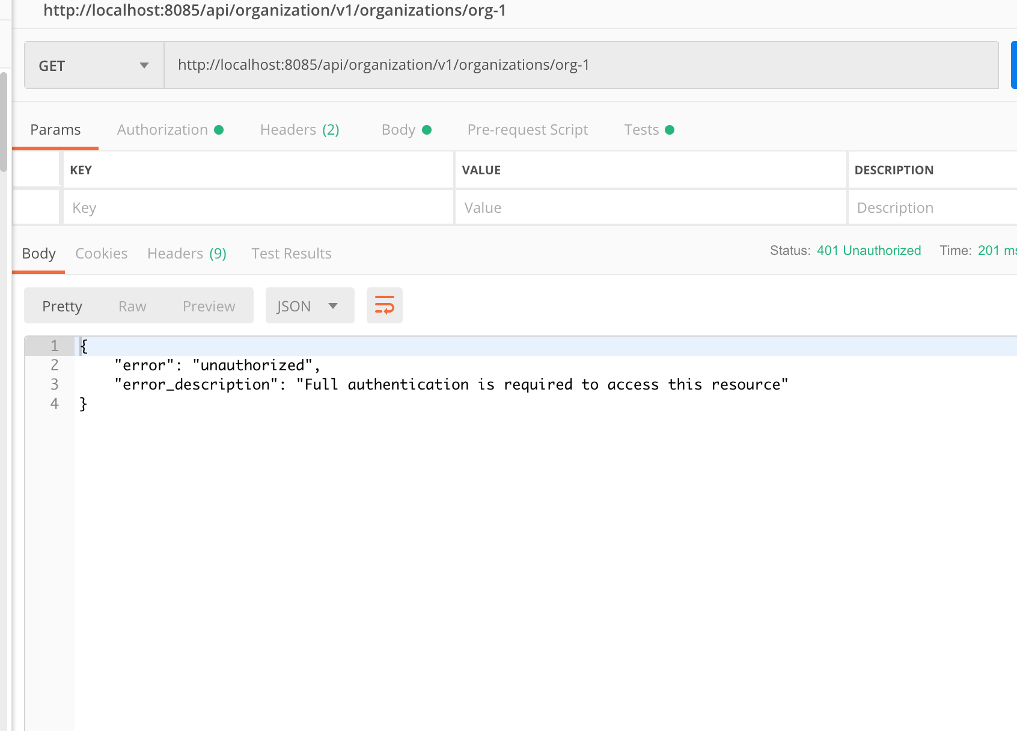

Attempting to get token.

Introducing username, password, grant type and scope to the body.

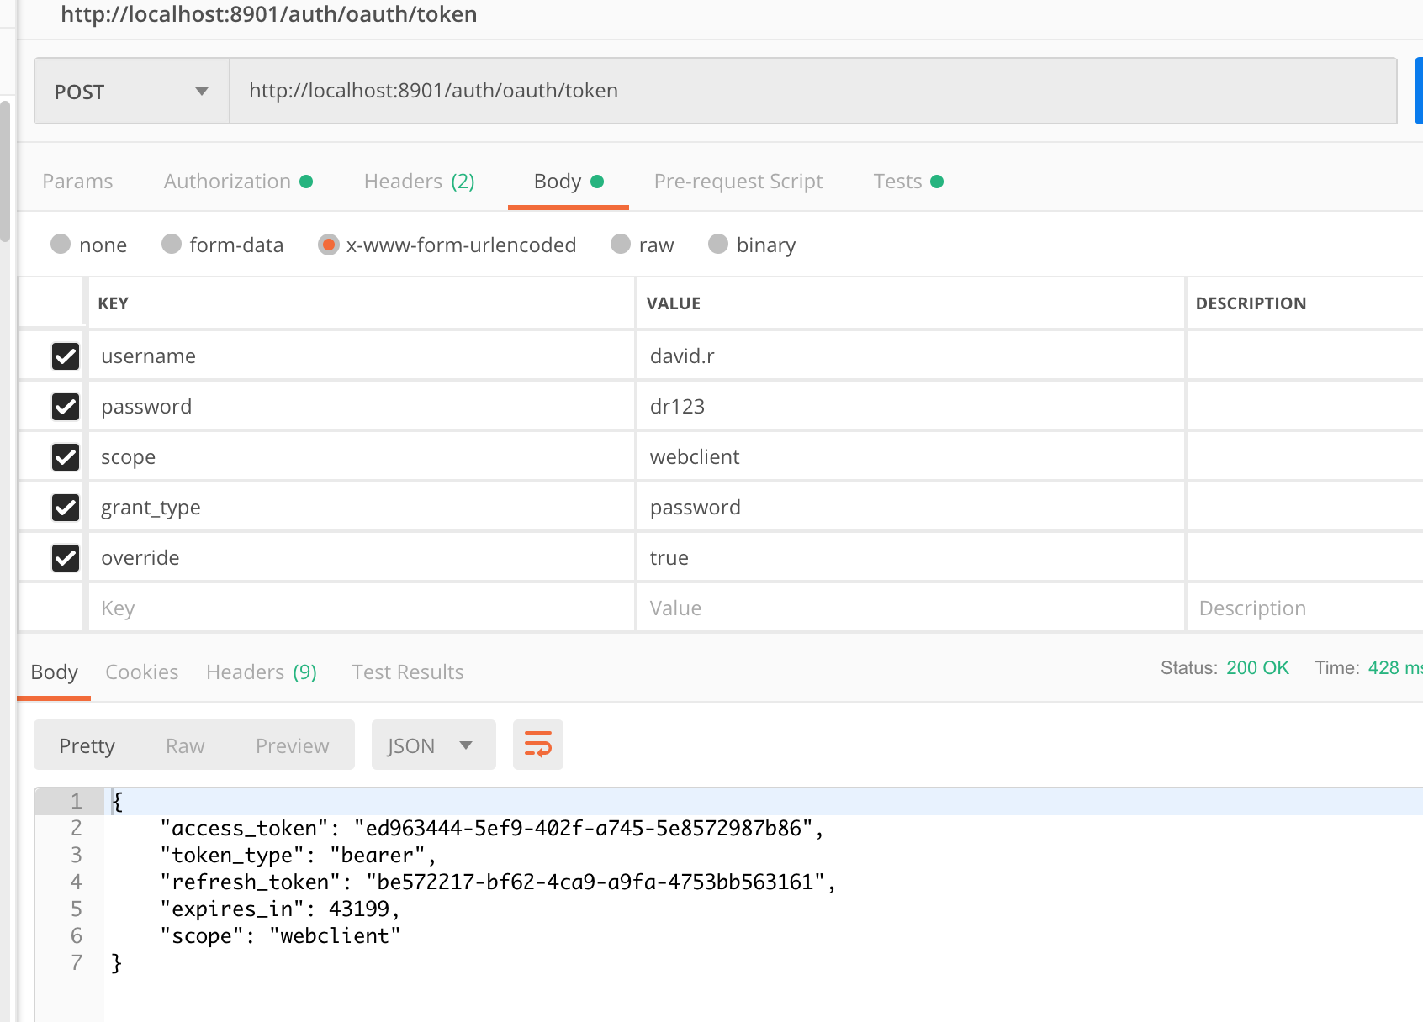

Setting authentication for getting token using username and password basic authentication:

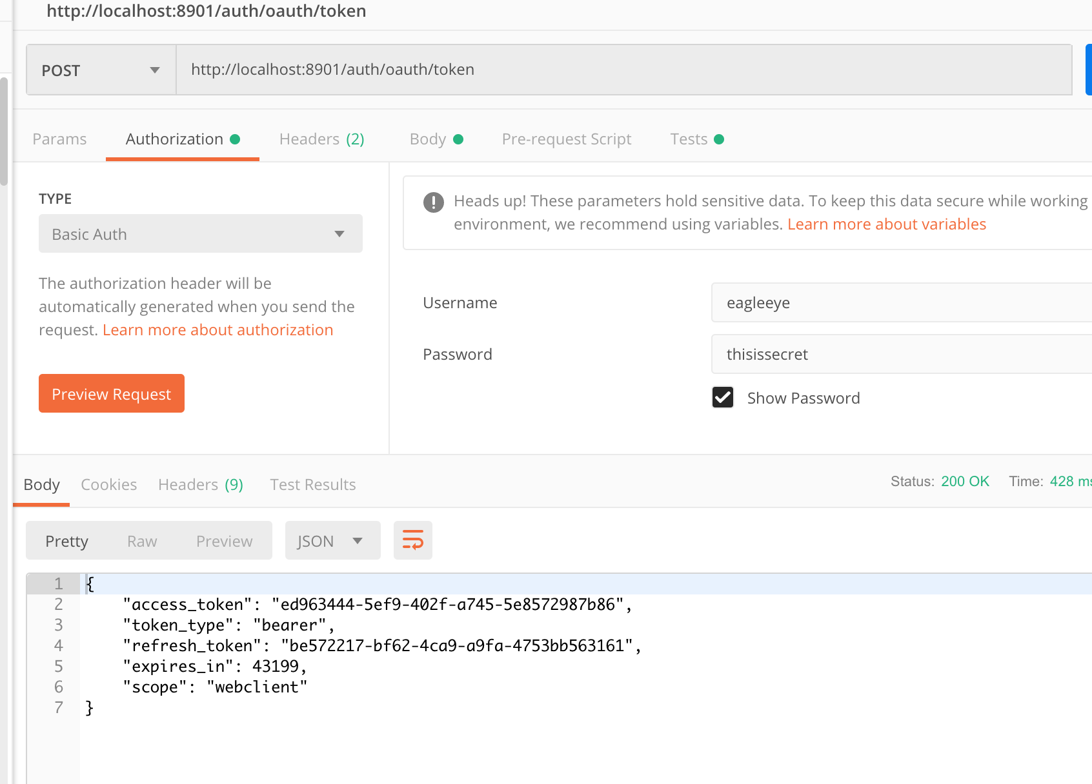

Introducing a script to referesh token :

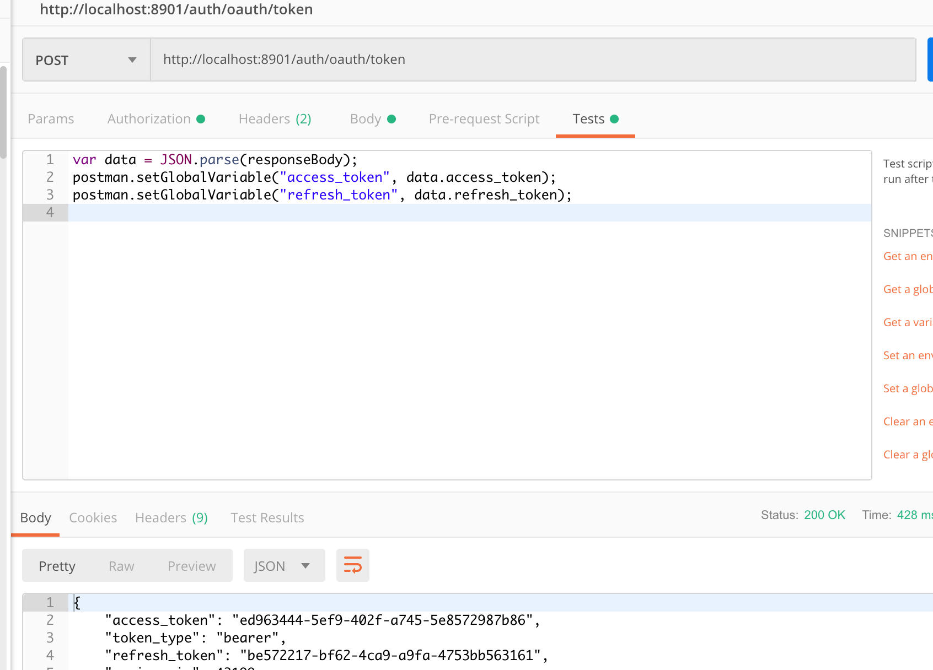

Getting organization with bearer token.

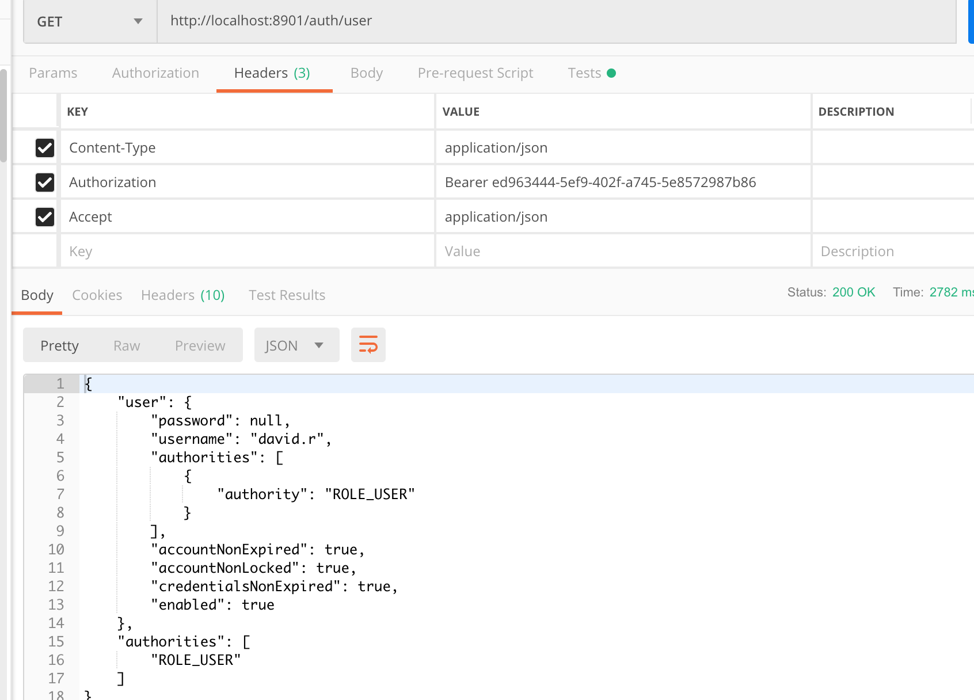

Use Case 2: Protect a service via a Specific Role.

User Ester.N has both user and admin roles.

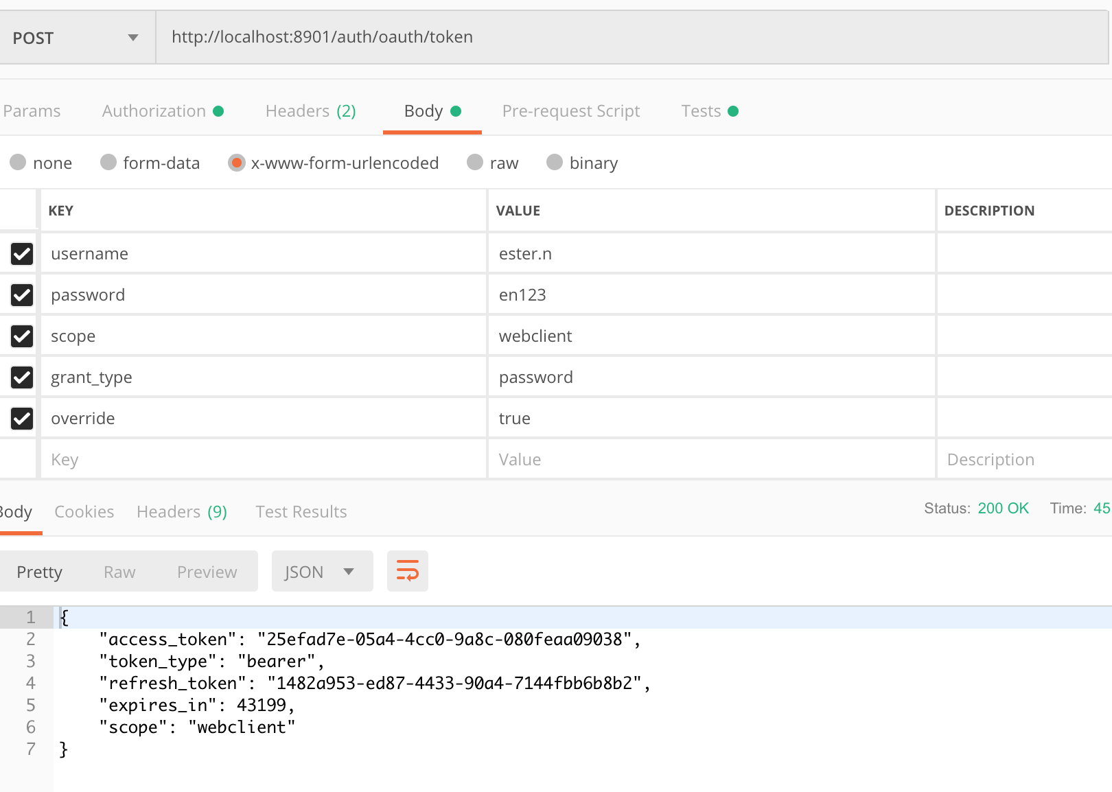

Calling auth/user :

